Name:
Professor:
Course:
Date:
Compare and Contrast Benin Plaque and Veranda Post
Benin plaques are works of art that were used to decorate the royal palace of the kingdom of Benin in the 13th century. Over a thousand plaques were made to decorate the king’s palace and as a way of showing wealth and power. One of the Benin plaques is the Brass plaque of a European, which shows the relationship between the king and Europeans. A veranda post is another form of art that was used to decorate the courtyard of a Yoruba palace. This artwork was used to show power and leadership. An example of a veranda post is the Veranda Pot of Enthroned King and Senior Wife by Olowe of Ise. There are various similarities and differences between these artworks as discussed below.
One of the similarities is that the heads in the artworks are fitted with crowns to show the position of power and wealth. In the Yoruba kingdom, the king was believed to have the highest veneration, a deity, who controlled the people, resources, and trade between Africa and Europe. The crown was symbolic of the head of the kingdom who had the control of the administration. Another similarity is on the use of color. In both works, dull colors are used, which can be symbolic of the dark skin of Africans. Africans were differentiated from other races by their skin color, which at some point led to their colonization. Using dark color for the sculptures shows an appreciation of culture and traditions. The Brass Plaque of a European shows the figure of a man with an ornamentation on the neck, while in the Veranda Pot of Enthroned King and Senior Wife shows the king and the senior wife with decorations on their necks and hands. These ornaments played a critical part in showing the roles and position of each in the kingdom.
Despite these similarities, there are differences that exist between the works, like the material used. For the Brass plaque of a European, the material used is brass, while in the Veranda Pot of Enthroned King and Senior Wife, the material used is wood. The difference in the use of material can be used to show the period when the artworks were developed and the main purpose, they were intendent to serve. Another difference is that in Veranda Pot of Enthroned King and Senior Wife, there are other figures like attendants, which are aimed to show the divine power of the king on earth through time. Another difference is the shape of the works. The Veranda Pot of Enthroned King and Senior Wife is three dimensional, as opposed to the Brass plaque of a European, which is two dimensional. The difference in the use of space allows viewers to have different views of the works, which, in turn, allow them to make varying inferences.
In conclusion, these two works of art excellently address the theme of government and leadership in Africa, particularly in Yoruba. They also portray how roles were designated and how they were discharged, in the context of leadership.
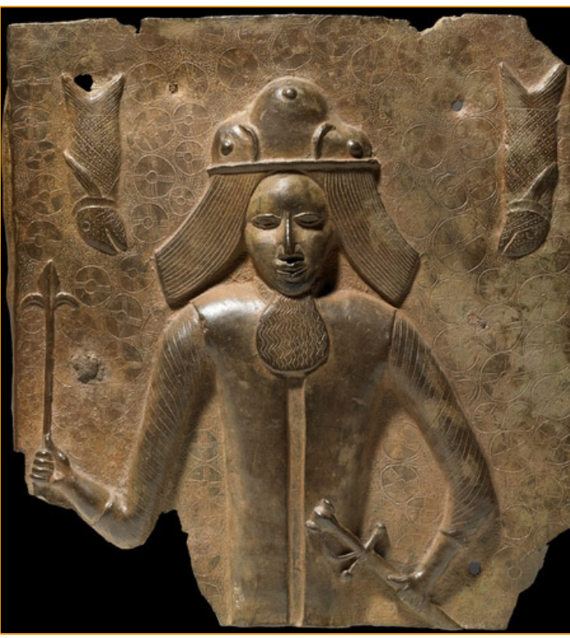
Brass plaque of a European, 16th century C. E., 39.5 × 37 cm, Benin, Nigeria. (British Museum).
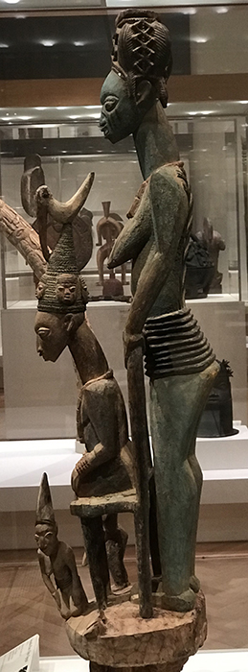
Olowe of Ise, Veranda Post of Enthroned King and Senior Wife. (Art Institute of Chicago).

Works cited
Khan Academy. Benin Plaques at the British Museum. (2020). Available at https://www.khanacademy.org/humanities/art-africa/west-africa/nigeria/a/benin-plaques
Smarthistory. Olowe of Ise, Veranda Post of Enthroned King and Senior Wife. (2020). Available at https://www.khanacademy.org/humanities/art-africa/west-africa/nigeria/a/olowe-of-ise-veranda-post-of-enthroned-king-and-senior-wife

